Topic: Revision Grammar. Infinitive. Date 26/03/2020
Group: Ac- 71
Write down the table in your notes.
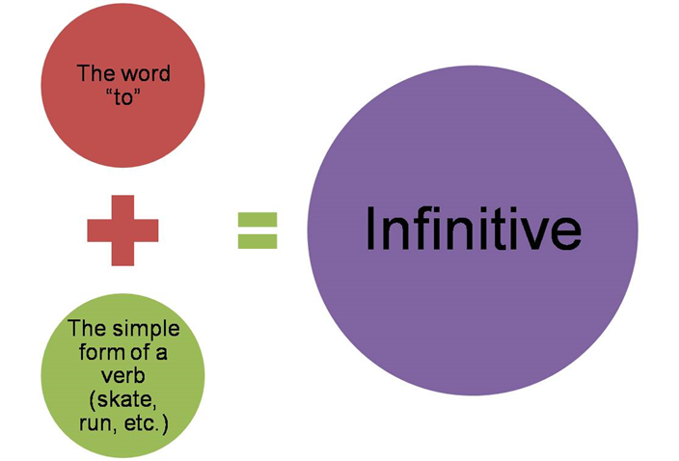
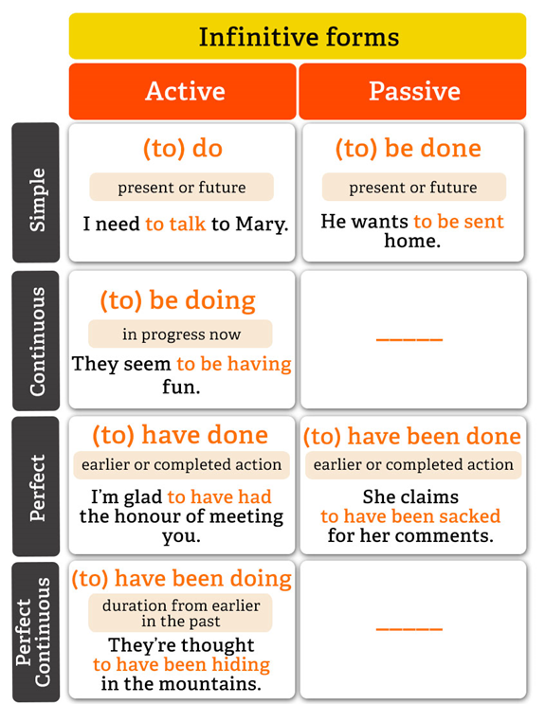
Task 1. Do the task on the website http://www.focus.olsztyn.pl/en-english-infinitives.html#.XnE57KAueM8

Task 2. Replace the subordinate clauses by infinitives in various functions.

Model
A: The child is very proud that he pressed the button in the lift.
B: The child is very proud to press the button in the lift.
- I am proud that I have completed this work by the 1-st of June.
- We are glad that we have seen this game.
- There is a lift in the house, which takes us to the upper stories.
- She said she was sorry that she had missed you.
- I am sorry that I did not come on Friday.
- We have a comfortable bed in which you can sleep.
- He bought some beautiful pictures, which he will hang in his study.
- Ann was surprised when she heard Peter’s voice.
