Topic: Youth. Date 18/03/2020
Group: E- 71
Task . Do exercise 1, 2, 3 on page 232

https://4book.org/uchebniki-ukraina/11-klass/407-anglijska-english-11-klas-karp-yuk/unit-7-focus-on-youth/page-236

Topic: People and society. Date 18/03/2020
Group: E- 71
Task . Do exercise 2 on page 237, exercise 3 on page 239

Topic: Political system of the USA. Date 18/03/2020
Group: E- 71
Task 1.
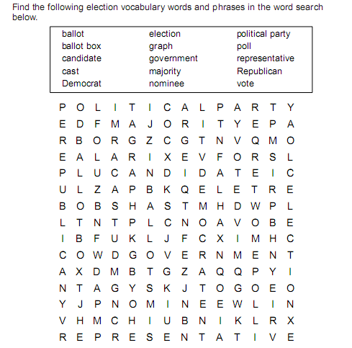
Task 2. Match the words with their definitions.
The President | We elect the Congressmen and the president.
The Vice President | I am the head of the US Administration.
The Secretary of the State | We make laws and we can introduce a new project.
The Congressmen | I can replace the President in case his death or his impeachment.
The People | I’m the head of the Cabinet

Task 3.Watch the video and write down three branches of the government in the USA.
https://yandex.ua/video/preview/?filmId=16690254828085690807&noreask=1&parent-reqid=1584477529968927-1694087467746623097100143-sas3-5180&path=wizard&text=political+system+of+the+usa+video
Task. 4. Read the texts and match the branch to its description

