Topic: Infinitive. Date 18/03/2020
Group: Eзв- 72
Write down the table in your notes.
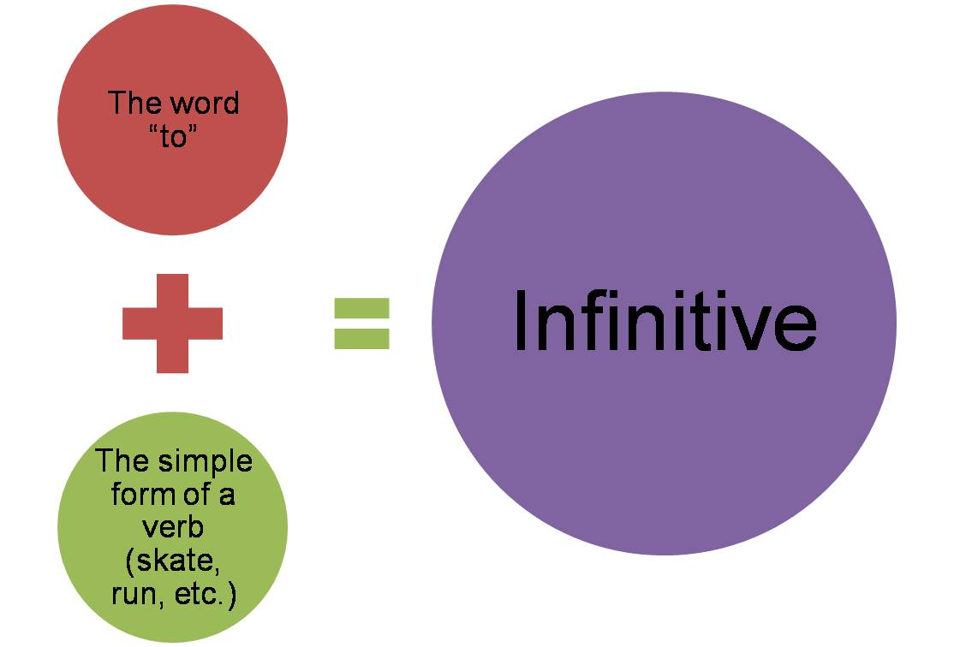

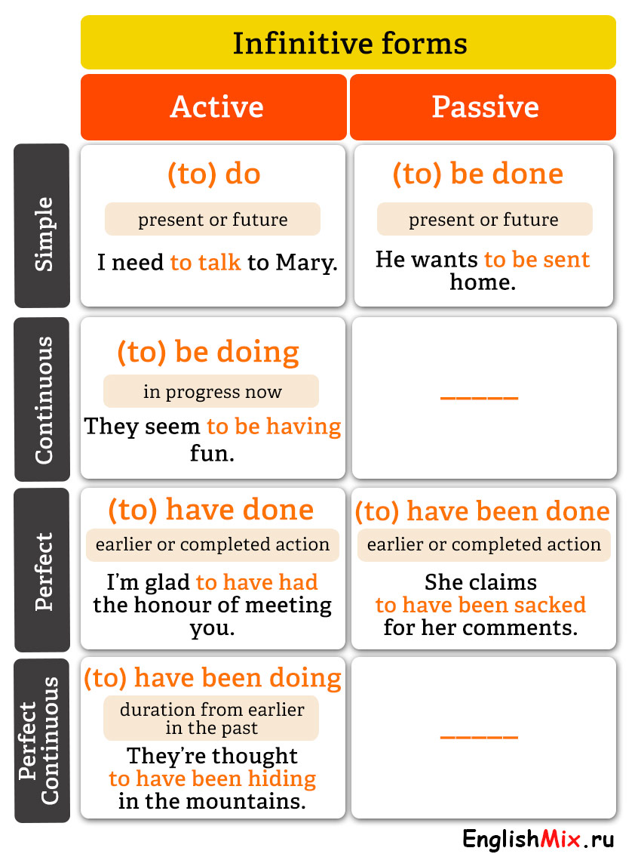
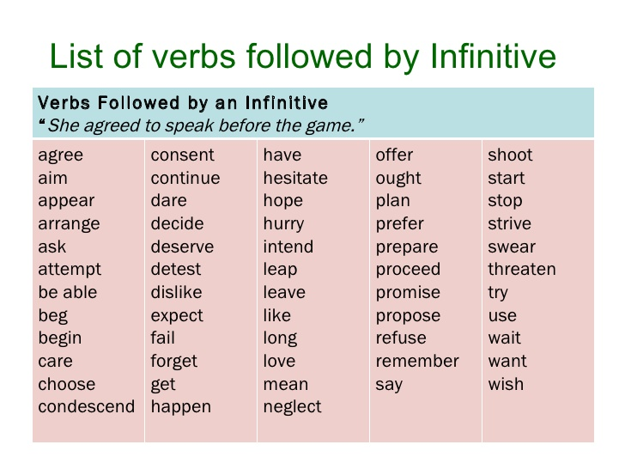
Task 1. Do the task on the website http://www.focus.olsztyn.pl/en-english-infinitives.html#.XnE57KAueM8

Task 2. Replace the subordinate clauses by infinitives in various functions.

Model
A: The child is very proud that he pressed the button in the lift.
B: The child is very proud to press the button in the lift.
- I am proud that I have completed this work by the 1-st of June.
- We are glad that we have seen this game.
- There is a lift in the house, which takes us to the upper stories.
- She said she was sorry that she had missed you.
- I am sorry that I did not come on Friday.
- We have a comfortable bed in which you can sleep.
- He bought some beautiful pictures, which he will hang in his study.
- Ann was surprised when she heard Peter’s voice.

Topic: Bare Infinitive. Date 18/03/2020
Group: Eзв- 72
Write down the table in your notes.
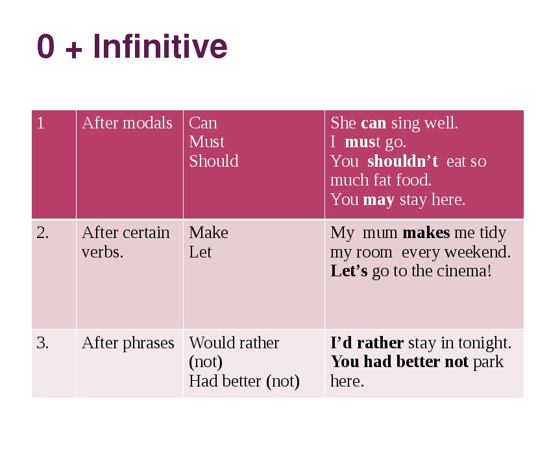
Task. Use the words to make sentences.
Example:
may | take | you | it - You may take it.
wash up | today | needn't | you ................................................................................................................................ yesterday | in the sea | we | swim | see | you ................................................................................................................................ someone | last night | hear | I | cry ................................................................................................................................ birds | to | we | fly | watch | the south | every year ................................................................................................................................ for you | me | do | it | let ................................................................................................................................ so often | laugh | they | make | me ................................................................................................................................ have | I'd | a milkshake | rather | ................................................................................................................................ start | better | immediately | we'd ................................................................................................................................ the house | her | decorate | I | help | last month ................................................................................................................................ your | must | parents | listen | you | to

Topic: Participle. Date 18/03/2020
Group: Eзв- 72

