Topic: Revision Grammar. Gerund. Date 23/03/2020
Group: Ac- 73
Watch the video https://www.youtube.com/watch?v=TU0Pg1StFmU
Write down the table in your notes
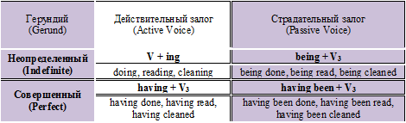
Task 1. Open the brackets and change the verbs into Gerund.
- Start … about pleasant things — and you’ll be happy! (think)
- Americans enjoy … houses and … to new places. (change/ move)
- Would you like to go … in the sea? (sail)
- Most people enjoy … in the sun. (lie)
- I haven’t had my lunch yet. Do you mind … outside for ten minutes? (wait)
- John likes … at a high speed. (drive)
- Stop … about your troubles. (worry)
- Jack was proud of … the first prize for…. (get/ jump)
- Helen was so angry that she left without… a word. (say)
Task 2. Change the verbs into Gerund and fill in the dialogue.
cook, sleep, spend, hike, talk
A What’ s the best way to relax?
В Well, I love … in the country. And you?
A Yeah, but I dislike … on a campfire and can’t stand … on the ground!
A Oh, where’s your sense of adventure? And I bet you hate … a week without your mobile phone.
В That’s true. I quite like … to people.
Topic: Revision Grammar. Infinitive. Date 23/03/2020
Group: Ac- 73
Write down the table in your notes.
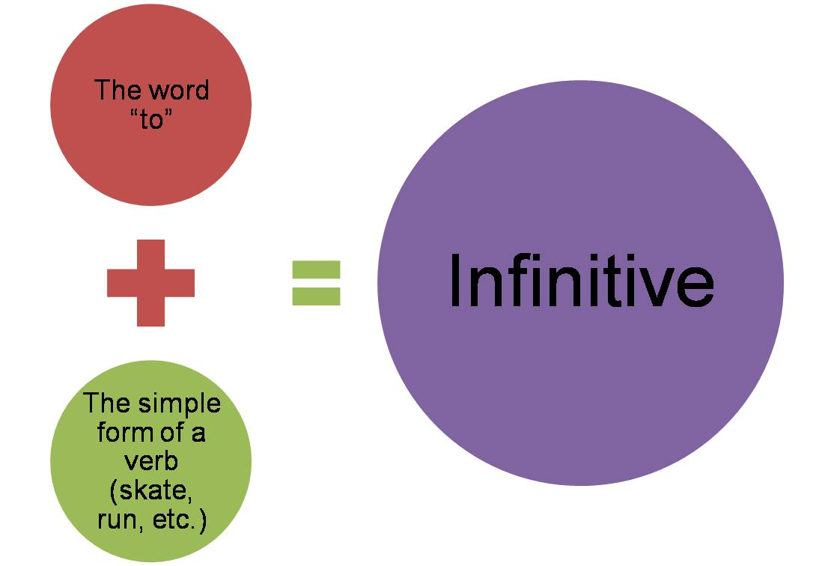

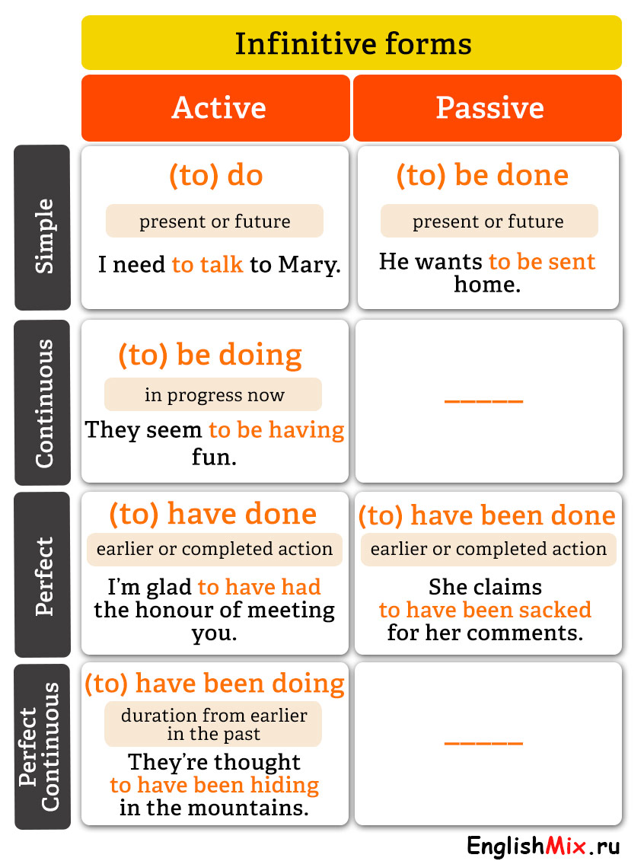
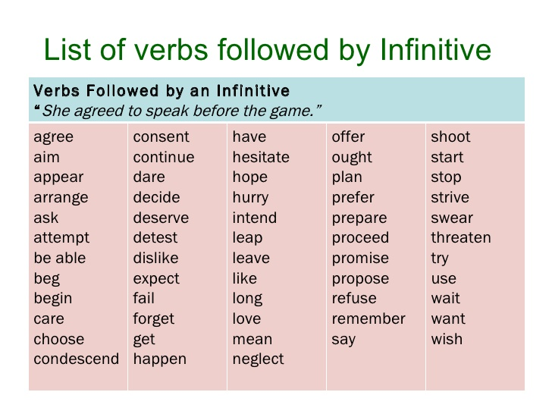
Task 1. Do the task on the website http://www.focus.olsztyn.pl/en-english-infinitives.html#.XnE57KAueM8

Task 2. Replace the subordinate clauses by infinitives in various functions.

Model
A: The child is very proud that he pressed the button in the lift.
B: The child is very proud to press the button in the lift.
- I am proud that I have completed this work by the 1-st of June.
- We are glad that we have seen this game.
- There is a lift in the house, which takes us to the upper stories.
- She said she was sorry that she had missed you.
- I am sorry that I did not come on Friday.
- We have a comfortable bed in which you can sleep.
- He bought some beautiful pictures, which he will hang in his study.
- Ann was surprised when she heard Peter’s voice.

