Topic: Political system of Ukraine. Date 24/03/2020
Group: 74
Task 1.Read some information about the political system of Ukraine and summarize it.
1)What is the general foundations of the political system?
2)What are the state power institutions in Ukraine?
POLITICAL SYSTEM
On August 24, 1991, Ukraine proclaimed its independence and during the referendum held on December 1 of the same year, the Ukrainian people confirmed their choice of independent development by saying “yes” to it. Leonid Kravchuk was elected the first president of a newly independent Ukraine. Ukraine faced a multitude of very difficult tasks which had to be solved within a short period of time: a new political system had to be built; new statehood principles based on law had to be introduced; a new system of national security and defense had to be created. In 1996 the new Constitution was adopted. General foundations of the political system of Ukraine are defined by its Constitution. In accordance with its organic law, Ukraine is a sovereign and independent, democratic, social and jural state. Democratic essence of the Ukrainian state is enshrined by the constitutional provisions concerning its form of government — a republic, governed by sovereignty of the people. State power is divided into legislative, executive and judicial branches, acting within their competence. The Constitution envisages the principle of political, economic and ideological diversity of social life. The social character of Ukrainian state results in constitutional regulation of issues related to the use of property and protection of all subjects of property right, social orientation of the economy, equality of all subjects of property right before the law, and the maintenance of ecologic safety and balance within Ukraine’s territory and other socially important measures. Jural essence of the state is supported by provisions related to supremacy of law and direct action of constitutional norms. The state is responsible to the people for its activities. According to the Constitution, the main task of the state is to establish and promote human rights and freedoms. Ukraine is a unitary state, in which its territory is integral and inviolable. The state has a single citizenship. The state language of Ukraine is Ukrainian.
THE PRESIDENT OF UKRAINE The Constitution of Ukraine designates the President as the Head of State, acting on its behalf. The President is a guarantor of national sovereignty, territorial integrity, adherence to the Constitution, human and civil rights and freedoms. The President is elected by the citizens of the state on the basis of equal and direct universal suffrage through a secret vote. The term of presidential office is five years. Only a citizen of Ukraine, who was residing in Ukraine for ten years before the elections, has voting rights and speaks state language, may be elected President. President may hold his / her post no longer than two consecutive terms.
THE VERKHOVNA RADA (PARLIAMENT) OF UKRAINE
The only legislative body of Ukraine is the Parliament — the Verkhovna Rada of Ukraine. People’s deputies of Ukraine are elected by the citizens of Ukraine on the basis of equal and direct universal suffrage through secret vote. The election system is mixed — majority and proportional. Altogether 450 deputies are elected. 225 of them are elected at singlemandate constituencies on the basis of relative majority, and another 225 are elected proportionally at multi-mandate national constituency from the lists of candidates coming from political parties and their election blocks. The powers of people’s deputies of Ukraine are established by the Constitution and laws of Ukraine. People’s deputies of Ukraine may voluntarily unite themselves into deputies’ groups called factions with no less than 25 members. Deputies’ groups are formed both on a party and a non-party basis. Deputies’ groups formed on party basis are called ‘factions’. Non-party deputies may join a faction if they support the program of relevant party. Deputies’ groups formed on a non-party basis unite deputies who share the same or similar views of national, social and economic development.
THE GOVERNMENT OF UKRAINE
The Cabinet of Ministers (Government) of Ukraine is the supreme executive authority. Its actions are based on the Constitution, laws of Ukraine and presidential orders. The Government is responsible to the President and is controlled by the Verkhovna Rada of Ukraine, to which it also must report. In practice, this dependency results in presidential appointment of a Prime Minister (with parliamentary consent). The President may also suspend Prime Minister’s authorities and discharge him / her. Upon Prime Minister’s submission, the President appoints and discharges the members of Cabinet of Ministers and other heads of central executive authorities. Parliamentary control of the Government and its reporting to the Verkhovna Rada results is parliamentary approval of government-submitted annual budget, parliamentary resolutions on fulfillment of budgetary provisions, approval or rejection of governmental program and control of government’s work.
THE SYSTEM OF JUDICIAL AUTHORITY
Legal proceedings are carried out by the Constitutional Court and courts of general jurisdiction. The supreme authority of the system of courts of general jurisdiction is the Supreme Court of Ukraine. Legal proceedings may be carried out only by courts. Courts’ jurisdiction covers all legal relationships in the state. The system of courts of general jurisdiction is based on the principles of territorial and special jurisdiction. The Constitutional Court of Ukraine is a separate entity and is independent from the courts of general jurisdiction. It cannot be used as a cassation, appeal or supervisory authority for the courts of general jurisdiction. The activities of the Constitutional Court of Ukraine promote constitutional control in all spheres, stabilization and strengthening of constitutional order, the establishment of principle of primacy of law and the supreme legal force of the Constitution, and the promotion of constitutional rights and freedoms of citizens.

Topic: Political system of the USA. Date 24/03/2020
Group: 74
Task 1.
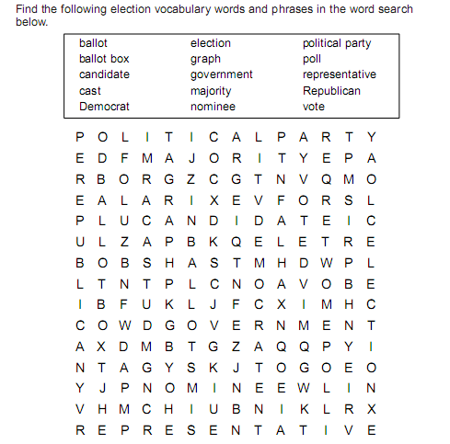
Task 2. Match the words with their definitions.
The President | We elect the Congressmen and the president.
The Vice President | I am the head of the US Administration.
The Secretary of the State | We make laws and we can introduce a new project.
The Congressmen | I can replace the President in case his death or his impeachment.
The People | I’m the head of the Cabinet

Task 3.Watch the video and write down three branches of the government in the USA.
https://yandex.ua/video/preview/?filmId=16690254828085690807&noreask=1&parent-reqid=1584477529968927-1694087467746623097100143-sas3-5180&path=wizard&text=political+system+of+the+usa+video
Task. 4. Read the texts and match the branch to its description
