Topic: Conditional sentences. Date 31/03/2020
Group: 81
Task 1. Watch the video! https://learnenglishteens.britishcouncil.org/grammar/intermediate-grammar/conditionals
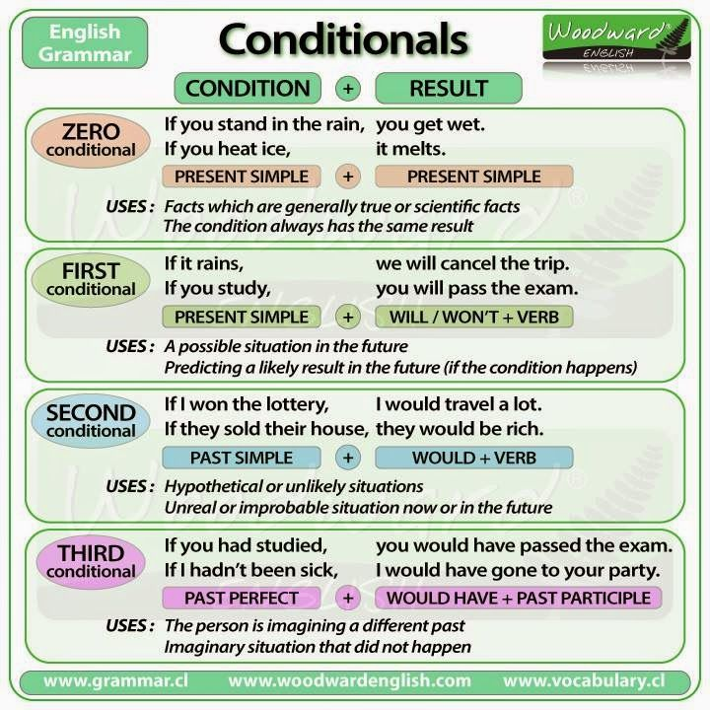
Task 2. Match the beginning of each sentence in A with its end in B.
A | B
1 I will phone you | a if you make so much noise.
2 If you wash the dishes, | b we won’t be able to play basketball
3 You will make Grandma very happy | c if I arrive before you.
4 If it doesn’t stop raining, | d if you visit her today.
5 John won’t be tired | e if he goes to bed soon.
6 The baby won’t sleep | f I will dry them.

Task 2. Circle the correct words.
1 Andrew will water the garden if he comes / will come home.
2 We will buy our tickets if we will have / have enough money.
3 We will be late for the show unless you hurry / will hurry.
4 I will take / take an umbrella if it rains.
5 If it is / will be a nice day tomorrow, we will go for a bike ride.
6 He won’t cross the road unless he will see / sees the green light.

Task 3. Complete the sentences with the verbs in brackets. Use the First Conditional.
1 If we ...................... (go) to London, we ...................... (visit) my friend George.
2 If she ...................... (do) well in her exams, my sister ...................... (go) to university.
3 Jenny ...................... (not eat) supper if she ...................... (eat) all that ice cream.
4 My brother ...................... (drive) us to the cinema if we ...................... (ask) him.
5 Uncle Tim ...................... (phone) us if he ...................... (want) to come with us.

