Topic: International exams. Date 31/03/2020
Group: 82
Task 1. Answer the questions.
1) Why do tourists go to France?
2) Why do tourists go to Italy / Spain / the USA / Ukraine?
3) Why do people go to banks?
4) Why do people go to post offices?
5) Why do people go to airports?
6) Why do children go to school?
7) Why are you learning English?
8) Why do you pass exams?
Task 2. Put the words and expressions from the list in suitable places in the network. Can you add some more?
adjectives | target | consonants | Ukrainian | intonation | German
languages | prepositions | present perfect | search | simple past | stress
resource | achieve

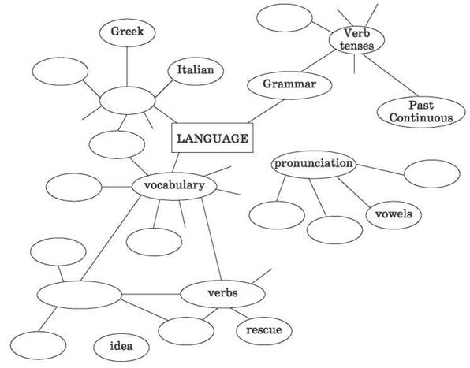
Task 3. How do you feel about subjects in the box? Use the following expressions to answer this question.
1)I really enjoy…
)I’m extremely interested in…
3)I’m fascinated by…
4)I’m quite interested in…
5)I’d like to know more about…
6)I don’t know anything about…
7)I’ve always wanted to learn something about…
8)I’m not very interested in…
9)I don’t much like…
10)I don’t like… at all.
11)I’m bored with
12)I hate…
13)I think… is a complete waste of time.
14)I used to like…, but I’ve lost interest in it.
15)I used to think… was boring, but now I’m getting interested in it.

Task 4. Answer the questions.
1) What is your favorite subject?
2) What subjects are you best at?
3) What subjects are you worst at?
4) What is the most difficult subject?
5) What is the easiest subject?
6) What foreign languages do you learn?
7) Who is your favorite teacher? Why?

Topic: Writing Test. Date 31/03/2020
Group: 82
Task 1. Complete the following sentences using appropriate active or passive verb forms. Choose your answers from the given options.
1. The problem …………………. to the children. (explained / was explained)
2. Those pyramids ……………………. around 400 AD. (built / were built)
3. All the trouble ……………………….. by your mother. (has caused / was caused)
4. The visitors ……………………. (were shown / have shown) a collection of old manuscripts.
5. I …………………. him ten thousand pounds last year. (lend / lent / was lent) 6. She …………………… of spiders. (frightened / is frightened)
7. That picture …………………. by my grandmother. (painted / was painted)
8. I ………………….. by his attitude. (shocked / have shocked / was shocked)
9. Excuse the mess. The house ………………… (is painting / is being painted / has painted)
10. I knew why I …………………. (had chosen / had been chosen)

Task 2. Write one word to complete each conditional sentence.
1. If I _______________ enough money, I'd buy a car.
2. If I _______________ to Dan's party, I'll call you.
3. I _______________ sleep better if I didn't have to share a room.
4. _______________ you call me when you get there?
5. If I _______________ have too much homework to do this weekend, I'll come out with you.
6. I’d _______________ really bored without my phone!

Task 3. Translate into English.
1) Хто вміє грати на піаніно? — Моя сестра вміє.
2) Коли він повинен повернути фотоапарат? — Він повинен повернути фотоапарат сьогодні.
3) У якому віці ваш брат умів читати? — Він умів читати у шість років.
4) Що їй можна робити? — Вона може подивитись мультфільм.
5) Куди Пітер має покласти ключ? — Він має покласти ключ на полицю біля дверей.
6) Хто має читати доповідь? — Доповідь має читати представник нашої делегації.

Task 4. Write an informal letter of about 100 words. Use all the details given. Do not write any dates and addresses.
You have decided to change your school to study foreign languages. One of your friends already studies at such a school. Write a letter to him/her in which you:
tell him/her the news
explain the reasons of your choice
show the importance of knowing foreign languages in your every day life, your future profession etc.
ask his/her advice on the number of languages you should choose and why.

