Topic: Writing application letter. Date 17/03/2020
Group: E- 81
Task 1: Read the letter and fill in the gaps with suitable word.
•join •two •expand •spare •enclose •hearing •helping •as •fascinated •applying •interested •look
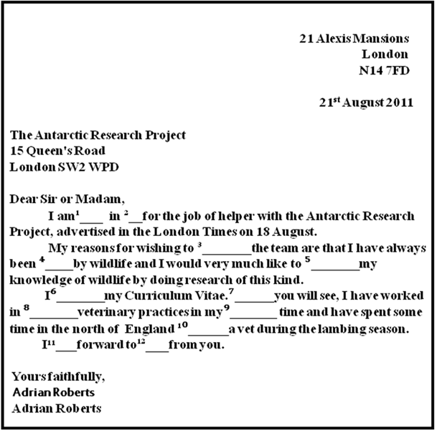
Task 2: Choose an appropriate preposition.
1. I don't like the idea of working in/for/by someone.
2. Paul joined us to/for/as a research assistant.
3. To join a team as/of /for experts, ring this number.
4. A knowledge in/of /for wildlife is desirable.
5. I have always enjoyed working for / with / by animals.
6. Send in a CV when applying in / to/for a job.
7. I am interested for/in/ to the job advertised.
8. Maria has always been fascinated in / with /by wildlife.
9. Sam represented his school of /at/with sports.
10. We look forward to /of /for hearing from you.
Task 3. Read the letter and find 13 mistakes.
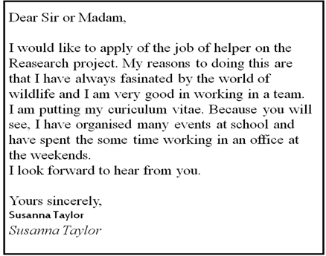
Send your answers on email ruzannadjavadyan@gmail.com

