Topic: Gerund. Date 17/03/2020
Group: Eзв- 72
Watch the video https://www.youtube.com/watch?v=TU0Pg1StFmU
Write down the table in your notes
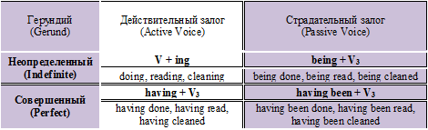
Task 1. Open the brackets and change the verbs into Gerund.
- Start … about pleasant things — and you’ll be happy! (think)
- Americans enjoy … houses and … to new places. (change/ move)
- Would you like to go … in the sea? (sail)
- Most people enjoy … in the sun. (lie)
- I haven’t had my lunch yet. Do you mind … outside for ten minutes? (wait)
- John likes … at a high speed. (drive)
- Stop … about your troubles. (worry)
- Jack was proud of … the first prize for…. (get/ jump)
- Helen was so angry that she left without… a word. (say)
Task 2. Change the verbs into Gerund and fill in the dialogue.
cook, sleep, spend, hike, talk
A What’ s the best way to relax?
В Well, I love … in the country. And you?
A Yeah, but I dislike … on a campfire and can’t stand … on the ground!
A Oh, where’s your sense of adventure? And I bet you hate … a week without your mobile phone.
В That’s true. I quite like … to people.
Topic: International organizations. Date 17/03/2020ational
Group: Eзв- 72
Task 1. Do exercise 3 on page 252, answer the questions
https://4book.org/uchebniki-ukraina/11-klass/407-anglijska-english-11-klas-karp-yuk/unit-7-focus-on-youth/page-236

