Topic: Political system of the USA. Date 6/04/2020
Group: 72
Task 1.
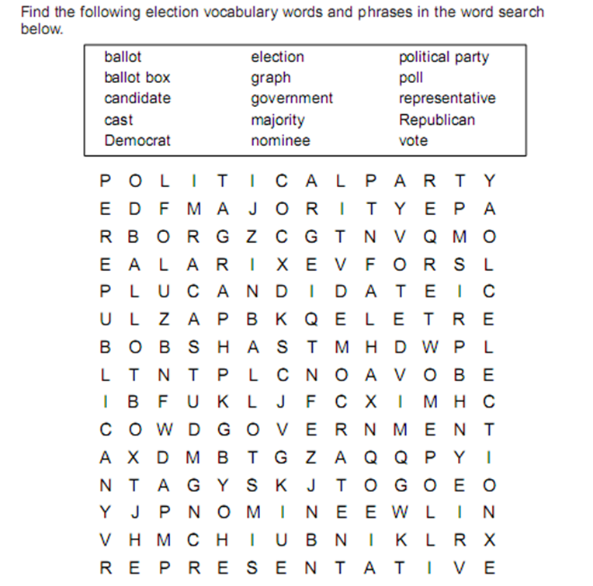
Task 2. Match the words with their definitions.
The President | We elect the Congressmen and the president.
The Vice President | I am the head of the US Administration.
The Secretary of the State | We make laws and we can introduce a new project.
The Congressmen | I can replace the President in case his death or his impeachment.
The People | I’m the head of the Cabinet

Task 3.Watch the video and write down three branches of the government in the USA.
https://yandex.ua/video/preview/?filmId=16690254828085690807&noreask=1&parent-reqid=1584477529968927-1694087467746623097100143-sas3-5180&path=wizard&text=political+system+of+the+usa+video

Task. 4. Read the texts and match the branch to its description
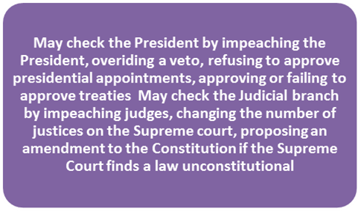
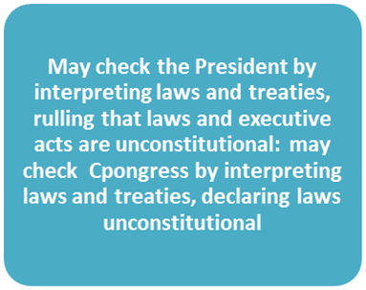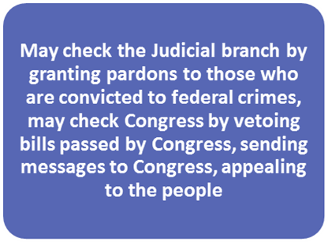

Topic: Political system of the UK. Date 6/04/2020
Group: 72
Task 1. Read and translate the text, say what its main points are.
MONARCHY IN BRITAIN
Great Britain is a monarchy, but the Queen of Britain is not absolute but constitutional. Her powers are limited by the Parliament. The Parliament is the supreme legislative authority in Britain. Queen's power is hereditary and not elective.
In practice the Monarch has no actual power: they say1 the Monarch reigns but does not rule. The Prime Minister is the virtual ruler of the country. The Prime Minister is usually the leader of the party that obtains a majority in the House of Commons. That party which has majority of seats in the House of Commons is called the Government and the other is the Opposition. The leader of the party in the opposition occupies a salaried office of the Leader of the Opposition. The Government may hold office for five years. All the affairs of the state are conducted in the name of the Queen but really the Prime Minister is responsible for every measure submitted to Parliament. The Queen summons, prorogues and dissolves Parliament2. Normally she opens each session with a speech from the throne outlining the Government's programme. It is her duty to make appointments to all important state offices, including those of judges, officers in the armed forces, diplomats. She must, in theory at least, see all Cabinet documents. The Queen has the power to conclude treaties, to declare war and make peace. The Queen has her own Privy Council3. The Cabinet developed from this Council, which used to be body of advisers of English monarchs. As the system of Cabinet developed the Privy Council declined in importance. The Privy Council consists of members of the royal family, the archbishops4, colonial governors and senior ministers. There are about 300 of them altogether. The committee of the Privy Council, the Judicial Committee, however, is the final court of appeal for the British — a Royal court. Queen Elizabeth II came to the throne in 1952 after the death of her father, King George VI. She has four children: one daughter and 3 sons. The Queen's heir is Charles, Prince of Wales. He was born in 1948, educated in Cambridge, served in the Royal Navy5. Now he is involved in various aspects of public life, in particular industry and government.
The Royal family is the principal aristocratic house in Britain, closely connected with other members of the hereditary aristocracy and with big finance interests. The Queen is known to be among the wealthiest women in the world.
Task 2. Choose the right word or word-combination.
1. The Queen's power is ...
a) elective b) hereditary c) unlimited
2. Prime Minister is the ... ruler of the country.
a) formal b) hereditary c) virtual
3. The Party which has majority in the House of Commons forms ...
a) opposition b) parliament c) government
4. It's the ... duty to make appointments to all important state offices.
a) Queen's b) Prime Minister's c) Lord Chancellor's
5. The Cabinet developed from ...
a) Privy Council b) Judicial Committee c) House of Lords

Task 3. Mark the statements that are true.
1. Great Britain is a constitutional monarchy.
2. The Queen's powers in Britain are unlimited.
3. The Prime Minister is the leader of the party which has majority in the House of Lords.
4. The Queen opens each session of Parliament with a throne speech.
5. The Privy Council is responsible for all government measures.
6. The Judicial Committee is the final court of appeal in Britain.

