SPEAKING . TEST
GROUP : С-11 DATE:13/05/2020
Task 1. For beginnings 11–16 choose the correct endings A–J. There are four
choices you do not need to use.
1. The English say, “My home …..  A is separated from the continent by the English
Channel.
2. The English proverb says,  B is America’s best known soft drink.
“East or west …  C is washed by the Pacific Ocean.
3. The UK …  D is my castle”.
4. An afternoon tea in Britain …
5. The spectacular Niagara Falls …  E is to know nothing.”
6. An eagle …  F home is best”.
 G is the official symbol of the USA.
 H consists of two parts which are separated by Goat Island.
 I is the oldest paper in Britain.
 J is between 4 and 5 o’clock

TASK 2
Answer the questions.

1.Do you like visiting art galleries and museums?
2.What English museums do you know?
3.What Ukrainian museums are famous all over the world?
4.What museums do you want to visit?
5.What is your favorite piece of art?

SPEAKING task 3
These are photos from your photo album. Choose one photo to describe to your friend.
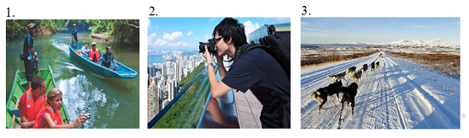
You will have to start speaking in 1.5 minutes and will speak for not more than 2 minutes (12–15 sentences). In your talk remember to speak about:
• where and when the photo was taken
• what/who is in the photo
• what is happening
• why you keep the photo in your album
• why you decided to show the picture to your friend
You have to talk continuously, starting with: "I’ve chosen photo number … ".

Please send the results : halya0067853@gmail.com
Or viber : 0950067853

